Wednesday Plan - 13th May 2020

Daily activities:
Spellings: Learn 4 spellings each day.
Reading: Read for at least 20 minutes.
Tables: Practice your multiplication tables (focus on x11 and x12 this week)
Gaeilge: Practice 5 questions of your choice and answer orally.
Whole-school event: Go to the Well-being Fortnight page for today’s activity!

1. English:
Today, we will be using our learning about using persuasive writing strategies to create a TV or radio advertisement!
- Watch this TV ad and listen to this radio ad. Think about these questions as you watch/listen:
- Who is the ad aimed at? How do you know?
- What words do they use to try to persuade you?
- How do they try to convince you to buy their product?
- Do you like the ad? Would you change anything?
- Mind map: take a look at the mind map below and think about what kind of ad you would like to create. You will have to fill in the answers to each box, before you create your ad. You can print the mind map, or do it in your copy.
- Finally, you have two options:
1. Log on to Seesaw to create a video/audio advertisement. You will see that the instructions have been created for you.
2. If you can’t record your TV or radio ad, you can create a poster ad instead.

2. Maths:
- This lesson is also available on Seesaw.
- Play ‘Division Facts’ on ‘Hit the Button’
- Today, we are learning about dividing with remainders. Watch Sarah’s video to find out more.
- Look at / do Planet Maths p.145

3. SESE:
Last week, we focused on some of the history of Australia and the Aboriginal people. Today, we are going to learn about the geography of Australia.
- Take a look at Google Maps and find Australia. Take a look at the names of the oceans around it and any nearby countries.
- Read the Powerpoint titled ‘All about Australia’, which will teach you about the country, some famous landmarks, the main cities and some animals you might find in Australia. As you go through the Powerpoint, fill in the answers to the activity sheet provided below.

Bonus Activity: Today, if you are looking for an extra challenge, why not try to build yourself a fort, just like in this video? You can then use your fort to relax, read, play games. Be sure to check in with your parents, before you start building!

English:
Advertisement - Mind Map
Fill in the answers to each of these questions, before you create your advertisement.
What am I advertising?
What is special about the thing I am advertising?
Who will my advert be aimed at – adults or children?
Why should they buy/use my product? How will it help them?
How much does it cost?
What things from my house will I need to make my advert?
Will I make a TV ad, a radio ad or a poster?
(Video or audio)

Maths:
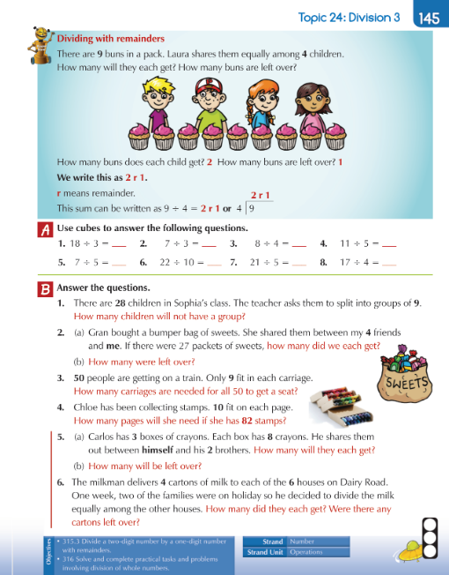

S.E.S.E:
