Tuesday Plan
Daily activities:
Spellings: Learn 4 spellings each day.
Reading: Read for at least 20 minutes.
Tables: Practice your multiplication tables (focus on x7 and x8 this week)
Dán: Practice the poem ‘Bláthanna’ (Flowers). Read the poem provided, or listen to our recording of it to help you.

- English:
- Today, we are going to revise capital letters and punctuation.
- Rewrite the passage on the ‘Grammar’ worksheet, putting in the correct capital letters, full stops and question marks.

2. Maths:
- Play this game to recap on symmetry. Try the ‘Pictures’ or ‘Shapes’ option for today.
- Take a look at this video of Orla explaining some more about symmetrical and asymmetrical shapes.
- Make a list of 10 things which you can see or find which are asymmetrical.
- Symmetry also depends on the colour of a shape. Look at/do p. 134 in Planet Maths.
- If you would like an extra challenge today, take a look at all of the flags of the world here and see if you can find any which are symmetrical - this might be difficult!

3. Science:
- Watch this video to learn about how an ear processes sound.
- Read pages 50 and 51 to learn more about how sounds are made.
- Put your fingers gently on either side of your throat, just under your chin. Hum or sing quietly, to feel your voicebox vibrating to make the sound! Try to hum at different volumes: loudly, very quietly, a high pitch, and a low pitch. Can you feel any differences?

4. Learn Together:
- Today, we are going to learn about a gurdwara - the building where Sikhs go to pray. Have a look at the Gurdwara powerpoint. You can also take a virtual tour of a gurdwara here, if you wish!
- In your copy, draw one image from a gurdwara. Here are some options:
- The outside of the building, with the symbol of Sikhism at the front
- The langar (kitchen) where the food is prepared
- The main prayer hall with the Guru Granth Sahib on a raised platform
- The entrance hall with place for everyone’s shoes and headscarves

Bonus activity: Take a virtual tour of Dublin Zoo here! You can also see some animals live on their webcams!

English:

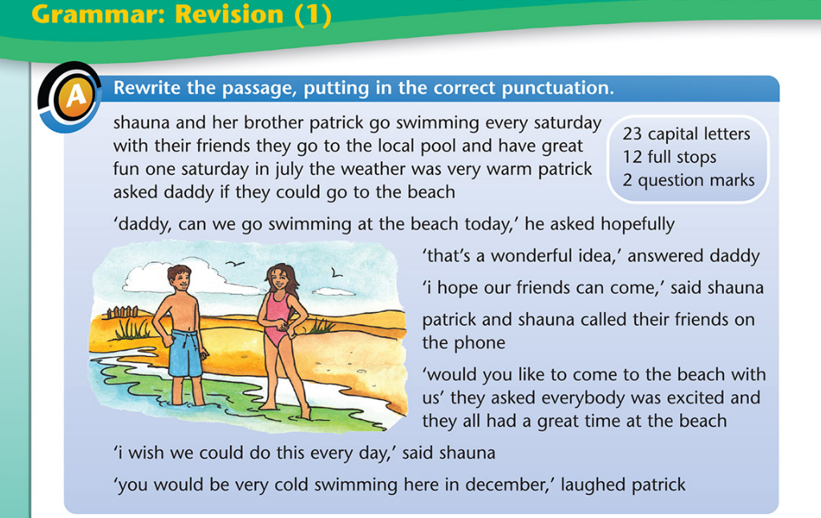

Maths:
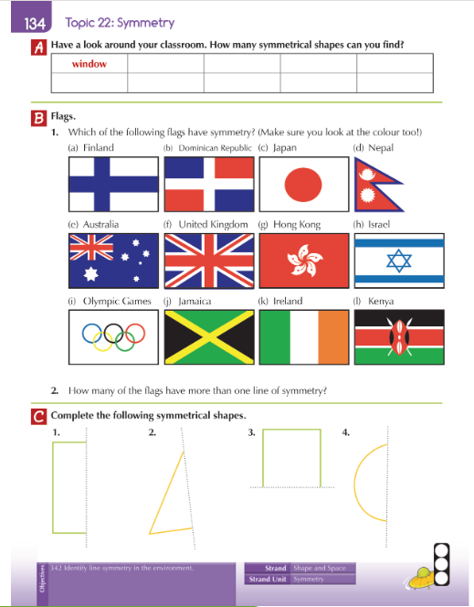

Science:
