Thursday Plan
Daily activities:
Spellings: Learn 4 spellings each day.
Reading: Read for at least 20 minutes.
Tables: Practice your multiplication tables (focus on x7 and x8 this week)
Dán: Practice the poem ‘Bláthanna’ (Flowers). Read the poem provided, or listen to our recording of it to help you.

- English:
- Today, we will be learning about antonyms. An antonym is a word that means the opposite of another word, e.g. good - bad, new - old.
- Complete activities A and B on the ‘Antonyms’ worksheet.

- Maths:
- Today, we will be doing some symmetrical drawing. You have three options to choose from for this - you should do at least one, but you can try as many as you like:
- Use the symmetrical drawing sheets provided.
- Create your own symmetrical drawing, showing the line of symmetry.
- Have someone in your family or house draw one side of a picture, and you can then try to draw the other side.
- Look at/do p. 136 in Planet Maths.

3. Science:
- As you learned earlier in the week, sounds are made when materials shake and vibrate, and this travels to our ears to hear it. Some animals who live in dark places, such as whales and bats, actually use sounds to find their way around their habitat and hunt for food. This is called echolocation. Read pages 54 and 55 about this.
- Watch this video to learn about how whales use echolocation in the dark oceans.
- In your copy, complete the questions on page 56. In these sentences, the blue words are wrong. Rewrite the sentences, and use the correct words to fill in right answers

4. Learn Together:
- We know that you have been seeing a lot about the government in recent weeks. This week, we are going to learn about the system of government that we have in Ireland and that is also in many other countries around the world - Democracy. Watch this video to understand what democracy is. It is an American video but it gives you an idea about how democracy works. Democracy in Ireland is similar but there are some differences which we will be learning about tomorrow.
- Talk to an adult at home: Why is democracy a good system? Can you think of any disadvantages of democracy?

Bonus activity: If you haven’t already sent a message or some learning to your teacher for this week, please do so now - they would LOVE to hear from you! If you already have that done, why not Skype or Facetime someone who you miss. Think of your grandparents or friends who you can’t see right now - I’m sure they are missing you too!

English:
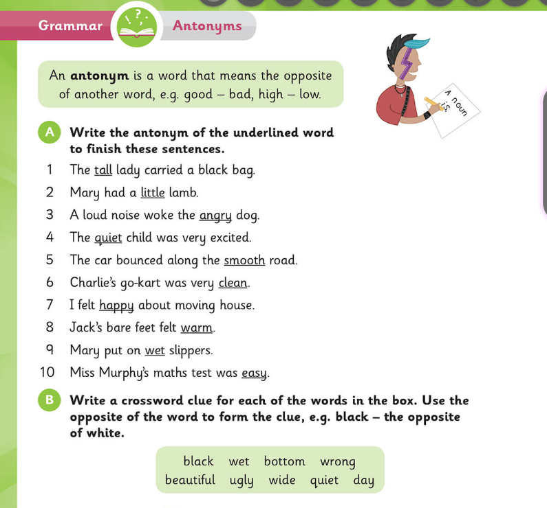

Maths:
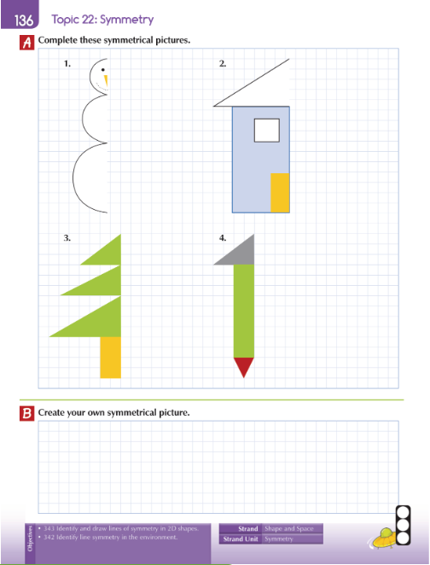
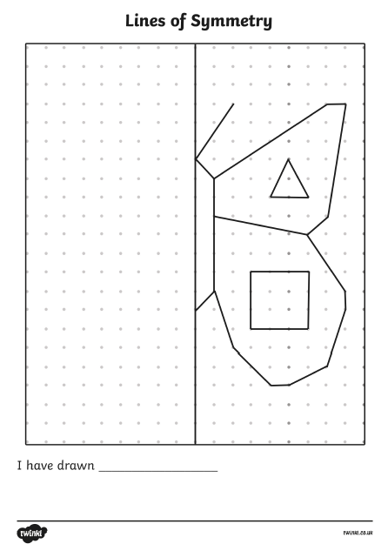
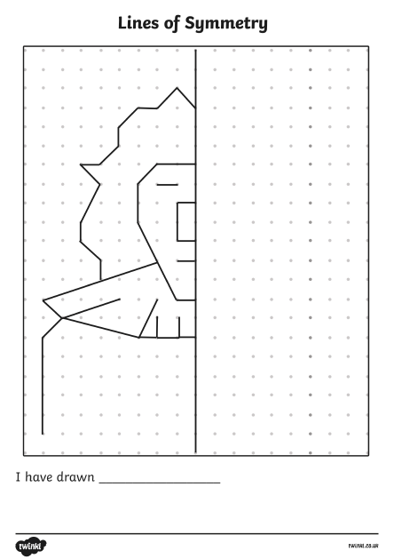

Science:
