Thursday Plan - 28th May 2020

Daily activities:
Spellings: Learn 4 spellings each day.
Reading: Read for at least 20 minutes.
Tables: Practice your division tables (focus on ÷3 and ÷4 this week)
Gaeilge: Practice 5 questions of your choice and answer orally.
Seesaw: Go to seesaw to revise the counties of Ulster today.
Whole-school event: Go to the Language page for today’s activity!

1. English:
- Today, we are going to do some dictionary work. Most of you should have your dictionaries from school now, but if you don’t have one, you can use the Cambridge Dictionary.
- Look at activity D on our reading comprehension page from this week. (A clearer version is available below.) Complete activities 1 and 2. This activity is also available on Seesaw.

2. Maths:
- Potion creation:
  - You are going to be creating a potion! It can be any kind of potion you choose (to become invisible, to fly, or anything else you can think of!). You have to decide the ingredients, and using millilitres, add them to your potion.
  - You have to have at least 4 ingredients, and you need to make 1 litre of potion, so add up your ingredients carefully!
- Look at/ do page 160 in your maths book. Some of these word problems are tricky, so try your best!

3. Gaeilge:
- Task 1: Seesaw: Watch the video to practice your new language for today. Listen and repeat each of the phrases.
- Task 2: Complete the interactive activities for today.
- Task 3: Complete p. 150 (C) in Abair Liom. This is also available on Seesaw, if you don’t have your book.
- Optional extra task - why not listen to Oldtown Road as Gaeilge, or find another song you know which has been translated to Irish!

Bonus activity: Create your own city of skyscrapers! Use coloured squares to create cuboids on your page. Draw windows and doors on your cuboids to make them into skyscrapers! Colour in the rest of your picture. Have a look at the example below. (If you are stuck for art ideas while you are at home, Pinterest is a fantastic site. There are endless ideas for art, drawing and crafts on it. There are also great recipe and activity ideas if you are interested too! You will need to create an account so ask your adult to help you.)

English:
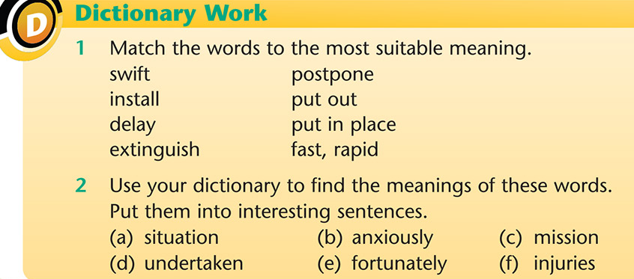

Bonus:
